**The Environment Will Kill Coal**

Colin Adams

HSA10 – The Economics of Oil and Energy

April 7th, 2016

# ***Introduction***

Coal has been a major part of the world’s energy for over a century. The coal industry has provided cheap electricity, thousands of jobs, and entire coal-mining towns. For many decades, this was the status quo. However, coal is failing today. Coal has been declining in use since 2008. Some of the biggest coal companies in the world have, or are threatening, to declare bankruptcy[1]. There is a crisis in the coal industry, so how can we explain it?

Coal is failing for two reasons. One of which is the environmental impact of coal consumption. The other, more prominent, reason is that the cost of cleaner sources of energy dramatically decreased over the past few years. This has made coal too dirty of a fuel for future investment in and is foundation for the death of coal as an energy source.

## ***Where Does Coal Come From?***

**Formation**

Coal is formed from large plants and other organisms that died in swamps around 300 million years ago.[2] Over the course of these 300 million years, the plants got buried deeper and deeper which increased the heat and pressure on the plant corpses. This combination of pressure and heat caused the plant’s organic matter to be transformed and compressed into a black, shiny rock which happens to burn significantly better than most other rocks. The location of where theses swamps were, is where coal is mined today.

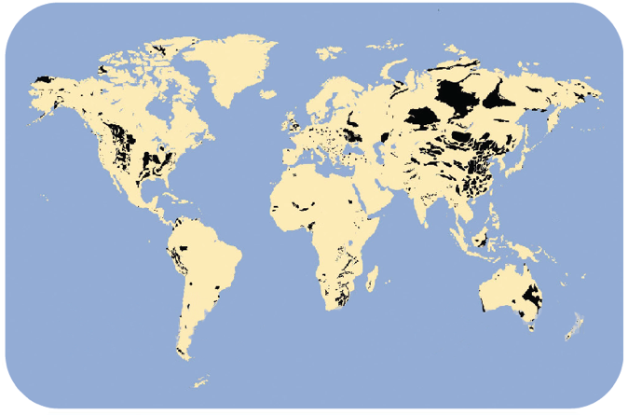 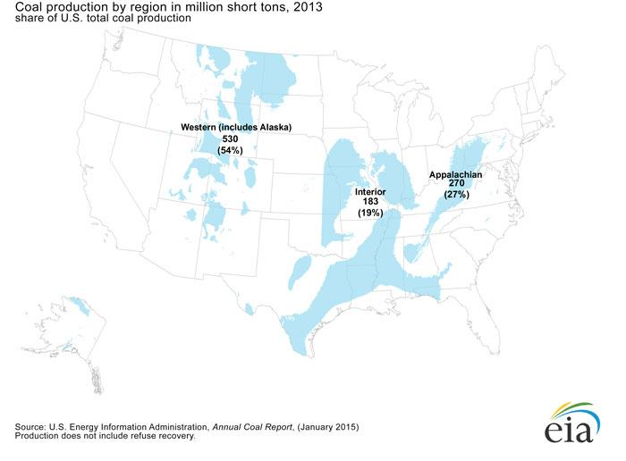

Figure 1: (Left) Coal Deposits Worldwide.[3]

(Right) Coal Deposits in US[4]

**Coal Mining and Its Environmental Impact**

There are two different methods of mining coal.[5] The first method is underground mining. This is the traditional form of mining in which underground shafts are created and coal is carted out. Underground mining is quite damaging to the environment. Methane that is trapped within the coal deposits is released when mined. When released into the atmosphere, methane traps about 30 times the heat that carbon dioxide traps, making it a much more potent greenhouse gas[6]. It is estimated that underground coal mining is responsible for 10% of methane emissions in the US each year.[7] Additionally, many of these mines leak acidic water that pollutes nearby lakes and streams as well as contaminates the groundwater. All of this is harmful to the ecosystem as well as costly to clean up.

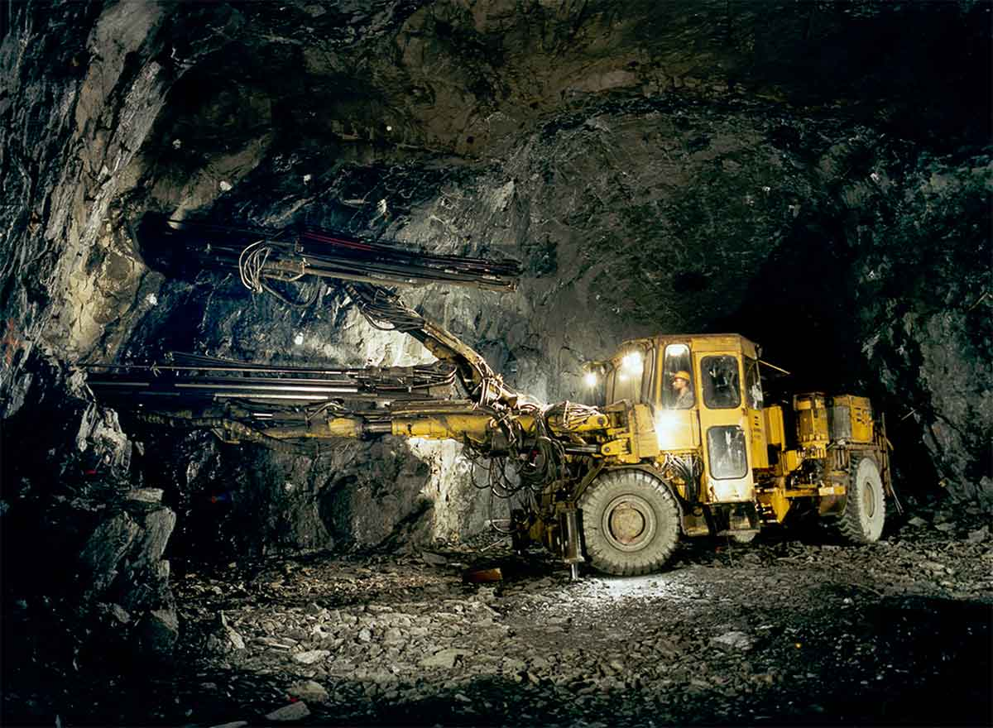

Figure 2: Example of Underground Mining[8]

The second technique for extracting coal is called surface mining. Surface mining includes a broad category of mining techniques where the miners don’t actually have to go underground to retrieve the coal. These techniques include strip mining and mountain top removal. When mining via mountain top removal, miners use explosives and other powerful machinery to literally remove the top of a mountain in order to reach the coal underneath. This method of mining is much more efficient economically. There are fewer workers required to extract the coal and there is a bigger yield. As one could imagine, this is very harmful to the environment.

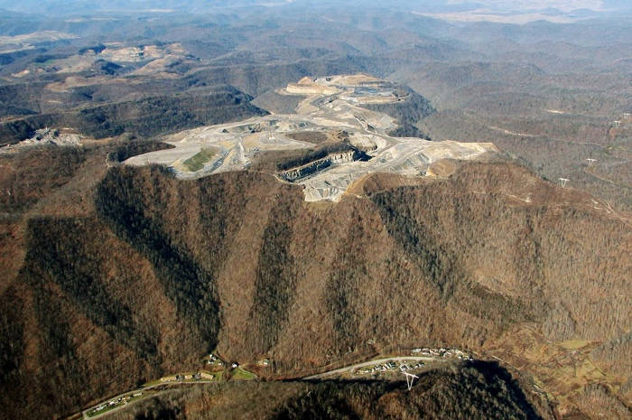 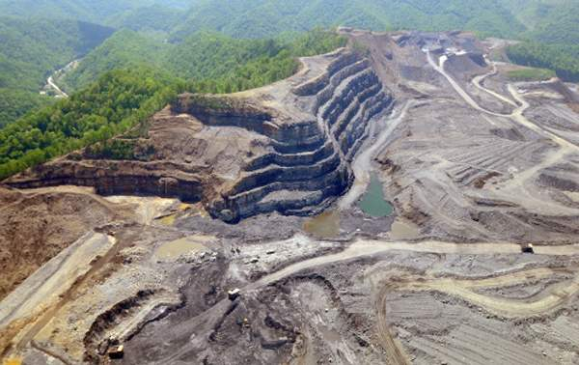

Figure 3: (Left) An Example of Mountain Top Removal Mining[9]

(Right) An example of strip mining[10]

Streams and rivers get diverted and polluted while ecosystems get destroyed when these huge amounts of rock are displaced. Frequently, coal companies go out of business and don’t pay to restore the natural environment, as they are required to do in the United States by law.[11] This forces the government, and consequently the tax payers, to pay for the restoration. For example, in just Wyoming alone, there are over $2 Billion in reclamation costs that coal companies are expected to pay.[12] However, lately, the coal industry has been struggling and many large coal companies are declaring, or threatening to declare, bankruptcy within the last few years.

Today, most coal is acquired by surface mining due to its efficiency and being less costly. The National Mining Association reports that in 2014, surface mines were responsible for 65.3% of coal production in the United States, producing 652,772 short tons of coal. To compare, underground mining produced the remaining 34.7% of coal which is about 346,879 short tons. In 2013, there was a ratio of about a 5 miners working for underground mines per every 3 miners working for surface mines. Consequently, a quick calculation shows us that

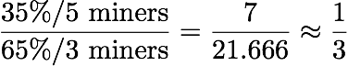

This means that surface mines are three times as productive per person as traditional mines. Thus, it is more economical for the coal industry to use surface mining as its main technique for extracting coal. This is shown in the price of coal. Coal mined from the surface costs $22.83 per ton while traditionally-mined coal costs $56.97 per ton. [13]

## ***What is Coal Used For?***

**Electricity Generation and Its Environmental Impacts**

About 93% of all coal is used for generating electricity in the United States, which is responsible for about 39% of all US electricity production.[14] Worldwide, coal is responsible for producing 41% of electricity.[15]

To produce this electricity, coal is ground up into a fine powder and then it is burned. The heat produced from this brings water to a boil. The steam from the boiling water turns a turbine in a generator, which produces the electricity which is then distributed through power lines to be consumed. The particles that remain from the coal after it is burned is called fly ash. In the United States, fly ash must not be released into the environment due to its damaging effects. However, many countries aren’t as strict.

This fly ash that is left over from burning the coal must be stored. This ash is usually stored near the power plant or put in a landfill. Occasionally, the storage container breaks or the coal ash leaks into the groundwater, which is very costly to clean up. Notably, this happened in Kentucky in October of 2000. An estimated 306 million gallons of coal slurry—which is a mixture of fly ash and water—was released into a nearby river, killing all aquatic life. The coal company responsible, spent a total of $49 million dollars in fines and clean up costs, and was at the time, one of the largest environmental disasters in United States history. It was 30 times the size, by volume, of the Exxon Valdez oil spill.[16] However, just eight years later 1.1 billion gallons of coal slurry was released in Tennessee costing an estimated $900 million to clean up. [17] [18]

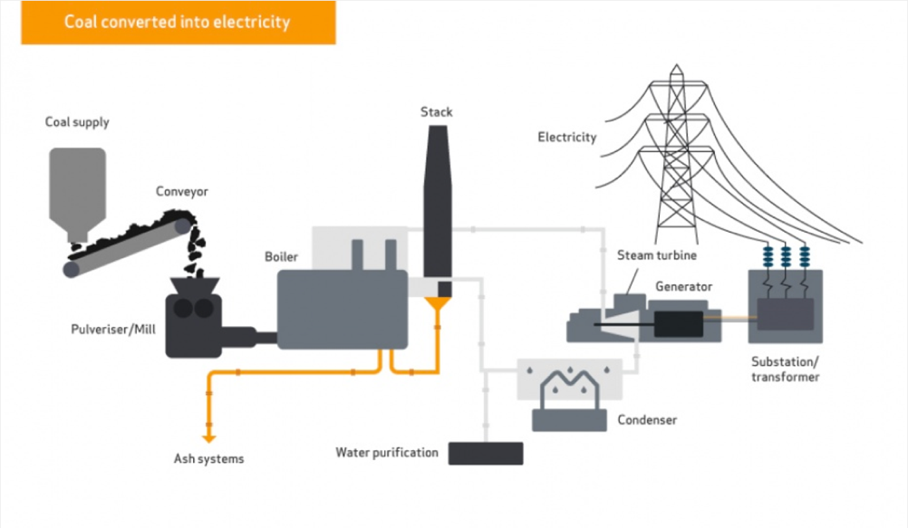

Figure 4: How Coal Produces Electricity22

Yet, most of coal’s environmental impact comes from its emissions when burned. Primarily, a huge amount of carbon dioxide gas is released per power plant per year. Carbon dioxide is a harmful greenhouse gas which is the main cause of climate change. However, the emissions of burned coal are more numerous than just carbon dioxide. When burned, coal releases significant quantities of sulfur dioxide, nitrous oxides, particulates, and toxic heavy metals like lead and mercury. Sulfur dioxide contributes to acid rain, nitrous oxides and particulates contribute to smog and is harmful to lungs, while toxic heavy metals, like mercury, are known to cause neurological damage[19]. As a result, coal is one of the dirtiest forms of energy.

## ***Coal vs Other Energy Sources***

After seeing where coal comes from and what it is used for, we must compare other sources of energy to see why coal is having its current crisis.

**Environmental**

As was seen, coal damages the environment at almost every stage of production, from extraction to emission. On average, coal is more damaging than any other source of energy to the environment. Let’s compare the environmental impact of coal against natural gas at three stages of its journey: extraction, transport, and consumption.

Natural gas is extracted by drilling a well deep within the ground, and letting the a mixture of oil and natural gas seep out to the surface.[20] The natural gas and oil become separated, and are then transported by a complex of pipelines to a processing plant where it is purified. Once refined, the natural gas is transported through more pipelines to its final destination to be burned. Once burned, the natural gas almost exclusively produces carbon dioxide due to the fact that natural gas is almost entirely made up by hydrocarbons such as methane.[21]

Compared to coal, natural gas is less harmful to the environment in every way. When extracted, drilling one deep well is less damaging than removing an entire mountain top or digging a deep complex of underground tunnels. As for transportation, coal is mostly transported by railway or boat­­­, while natural gas has pipelines. Yet, the biggest difference comes from when natural gas and coal are burned. As stated before, coal releases carbon dioxide, particulates, nitrous oxides, sulfur dioxide, and toxic heavy metals when burned. In comparison, natural gas produces almost exclusively carbon dioxide. In fact, natural gas produces 46% less carbon dioxide when producing the same amount of energy.[22] For every one kilowatt hour of energy coal produces, 0.74lbs of carbon dioxide is released. For natural gas, it only 0.40lbs of carbon dioxide are released.

**Economic**

If coal is so damaging to the environment, why is it so prominent? The answer: it’s cheap and there’s a lot of it. In fact, since 1950, the average price of coal has almost always been below $30 per ton when adjusted for inflation.

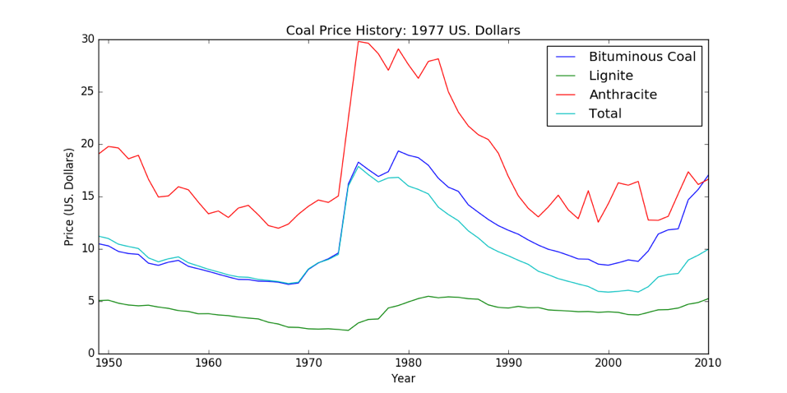

Figure 5: Price History of Coal

As we can see in the graph below, coal’s price over the past decade has always remained low and and has remained relatively constant. Over the same time period, the prices of oil and natural gas were much less consistent and had larger fluctuations. The current price of coal is around $0.09 per KWh of energy that is produced.

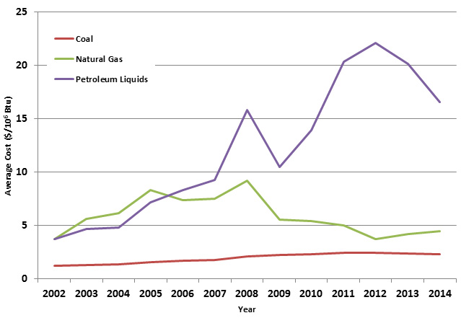

Figure 6: Price History of Coal, Natural Gas, and Oil

However, this isn’t the true price of coal. To calculate the true cost of coal, we need to consider all of the harmful health effects, all of the damage to environment, etc., all of which cost money. These are called externalities.

The true cost of coal, once external costs are accounted for, show that the world’s cheap electricity isn’t so cheap after all. As mentioned before, coal must be mined; when mined, the environment is damaged—sometimes terribly. Coal must then be transported, usually by rail—causing more pollution. Lastly, the coal is burned releasing harmful pollutants into the atmosphere, damaging the environment and creating health hazards for communities and the people living nearby. Imagine the health costs that Beijing faced in December 2015, when the air quality was seven times the safe limit for over three consecutive days.[23]

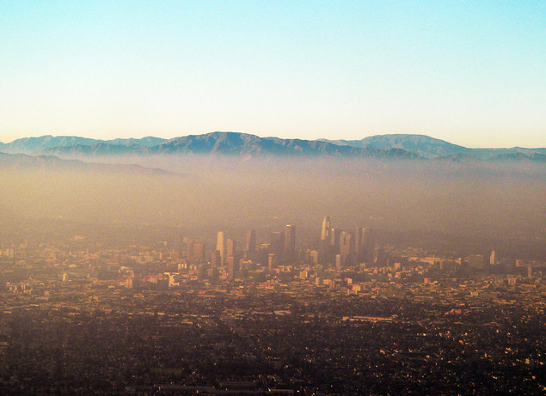 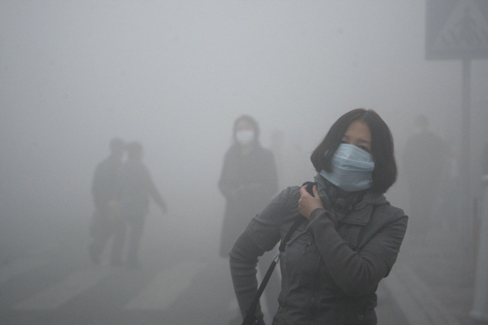

Figure 7: (Left) Smog in Los Angeles[24] and air pollution in Beijing[25]. (Right)

In fact, a Harvard Study quantified these externalities and estimated the true cost of coal. The study estimated that the true price of when considering these factors, add anywhere from an additional $0.09 per KWh to $0.269 per KWh to the current price. The Harvard Study concluded that the true price of coal was a total cost of $0.273 per KWh.[26]

On the other hand, natural gas has become much cheaper over the past few years and has fewer externalities. Over the past year alone, the price of natural gas has dropped over 60%.[27] At the same time, natural gas infrastructure and investment has grown. The current cost of producing a kilowatt hour from natural gas is $0.14.[28] This is nearly half of the estimated cost that the Harvard Study provided making coal both less economical and dirtier than the surging natural gas.

## ***The Decline and the Coming Death of Coal***

**Decline**

To put it simply, the coal industry is failing. Coal exports in the US went down by 23% in 2015.[29] Additionally, six major coal companies have declared bankruptcy in the United States within the last year, while others are on the verge of bankruptcy. For example, the largest coal company in the United States, Peabody Energy, is threatening to declare bankruptcy.[30] In 2011, the Peabody Energy stock was worth over $1000 per share. Now, it is worth less than $3.

This rapid decline of coal in recent years comes primarily from the decreasing price of cleaner alternative fuels. This is evidenced from the price of natural gas which has decreased sharply over the past few years in the United States.

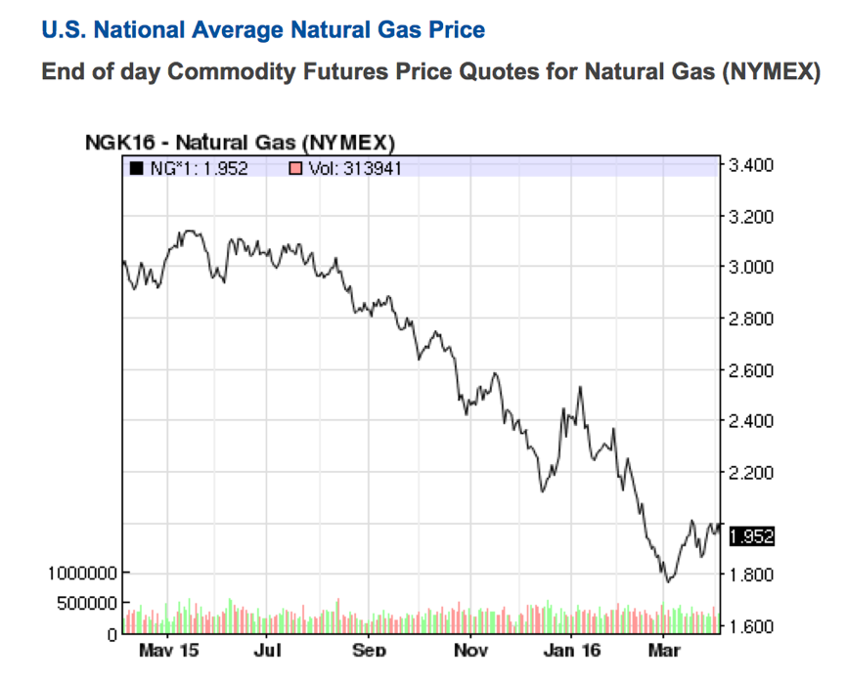

Figure 8: Price History of Natural Gas

The percentage of electricity that natural gas is producing is growing, while the amount that coal is producing is decreasing­–both domestically[31] and abroad.[32] The Energy Information Administration is reporting that coal production began declining in 2008 and that trend has continued up through 2015.[33] In 2014, the world coal market declined for the first time in 21 years, and it appears that 2015 did the same.[34] Not only this, but as we showed earlier, it makes economic sense for coal companies to use more environmentally damaging techniques to obtain and ship coal. In fact, when using the more environmentally-harmful method of surface mining, coal mining companies are about 3 times more efficient than when using the traditional method of underground mining.

**Coming Death**

The world is shifting away from coal and because of cheaper and cleaner energy sources. The majority of countries are starting to choose an investment in the protecting the environment over the promise of cheap energy. This is seen by the fact that 195 countries—virtually the entire world—agreed to the Paris Agreement in December of 2015, to reduce emissions.[35] In 2015, coal accounted for only one one-hundredth of one percent of new electricity generation in the US. Over the same period of time, over 80% of electricity generation that was retired in the US, was conventional, steam coal.

In short, the decline and death of coal happened in two punches. The first punch to coal was the fact that cleaner and more efficient sources of conventional energy are starting to take root in the energy industry, especially in the United States. The second punch is the environmental damage that coal imparts which actually raises its true cost. In essence, coal is too dirty for future investment.

[WORD COUNT: 2358]

1. "One Of The Largest Coal Companies In The United States Just Filed For Bankruptcy." *ThinkProgress RSS*. N.p., 11 Jan. 2016. Web. 07 Apr. 2016.
2. "How Coal Formed." *Coal Education*. N.p., n.d. Web.
3. "Conventional Coal Reserves." N.p., n.d. Web. 07 Apr. 2016.
4. "Where Our Coal Comes From." *- Energy Explained, Your Guide To Understanding Energy*. N.p., n.d. Web. 07 Apr. 2016.
5. "Coal Mining." *World Coal Association*. N.p., n.d. Web. 07 Apr. 2016.
6. "Understanding Global Warming Potentials." *Understanding Global Warming Potentials*. N.p., n.d. Web. 07 Apr. 2016.
7. "Overview of Greenhouse Gases." *Methane Emissions*. N.p., n.d. Web. 07 Apr. 2016.
8. "Underground Mining." *Mining Solutions*. N.p., n.d. Web.
9. "Images of Mountaintop Removal Mining." *Earthjustice*. N.p., 20 Oct. 2011. Web. 07 Apr. 2016.
10. "EPA Study Confirms Damage from Strip Mining." *Charleston Gazette-Mail*. N.p., n.d. Web. 07 Apr. 2016.
11. *Coal Reclamation*. Los Angeles Times, n.d. Web. 07 Apr. 2016.
12. "When Coal Companies Fail, Who Pays For The Cleanup?" *NPR*. NPR, n.d. Web. 07 Apr. 2016.
13. http://www.eia.gov/coal/annual/pdf/table28.pdf
14. "Coal." *EIA Energy Kids -*. N.p., n.d. Web. 07 Apr. 2016.
15. https://www.worldcoal.org/coal/uses-coal/coal-electricity
16. Sealey, Geraldine. "Sludge Spill Pollutes Ky., W. Va. Waters." *ABC News*. ABC News Network, 23 Oct. 2016. Web. 07 Apr. 2016.
17. "TVA to Ship Spilled Coal Ash." *Timesfreepress.com*. N.p., n.d. Web. 07 Apr. 2016.
18. *Tennessee Sludge*. Cable News Network, n.d. Web. 07 Apr. 2016.
19. "Coal." *EIA Energy Kids -*. N.p., n.d. Web. 07 Apr. 2016.
20. "Adventures in Energy." *Adventures in Energy*. N.p., n.d. Web. 07 Apr. 2016.
21. "NaturalGas.org." *NaturalGas.org*. N.p., n.d. Web. 07 Apr. 2016.
22. "U.S. Energy Information Administration - EIA - Independent Statistics and Analysis." *How Much Carbon Dioxide Is Produced When Different Fuels Are Burned?* N.p., n.d. Web. 07 Apr. 2016.
23. "Beijing's Smog 'red Alert' Enters Third Day as Toxic Haze Shrouds City." *The Guardian*. Guardian News and Media, 21 Dec. 2015. Web. 07 Apr. 2016.
24. "L.A. Smog." *Living in a Toxic World*. N.p., 20 Apr. 2011. Web. 07 Apr. 2016.
25. "Beijing - China Smog Emergency Shuts City Of 11 Million People." *Beijing - China Smog Emergency Shuts City Of 11 Million People*. N.p., n.d. Web. 07 Apr. 2016.
26. Epstein, Paul R., Jonathan J. Buonocore, Kevin Eckerle, Michael Hendryx, Benjamin M. Stout Iii, Richard Heinberg, Richard W. Clapp, Beverly May, Nancy L. Reinhart, Melissa M. Ahern, Samir K. Doshi, and Leslie Glustrom. "Full Cost Accounting for the Life Cycle of Coal." *Annals of the New York Academy of Sciences* 1219.1 (2011): 73-98. *Chgeharvard.org*. Harvard School of Public Health. Web.
27. "Commodities: Latest Natural Gas Price & Chart." *NASDAQ.com*. N.p., n.d. Web. 07 Apr. 2016.
28. "U.S. Energy Information Administration - EIA - Independent Statistics and Analysis." *U.S. Energy Information Administration (EIA)*. N.p., n.d. Web. 07 Apr. 2016.
29. "U.S. Energy Information Administration - EIA - Independent Statistics and Analysis." *U.S. Coal Exports Declined 23% in 2015, as Coal Imports Remained Steady*. N.p., n.d. Web. 07 Apr. 2016.
30. "U.S. Coal Sector Faces Reckoning." *WSJ*. N.p., n.d. Web. 07 Apr. 2016.
31. "U.S. Energy Information Administration - EIA - Independent Statistics and Analysis." *Nationwide, Electricity Generation from Coal Falls While Natural Gas Rises*. N.p., n.d. Web. 07 Apr. 2016.
32. "U.S. Energy Information Administration - EIA - Independent Statistics and Analysis." *Coal Use in China Is Slowing*. N.p., n.d. Web. 07 Apr. 2016.
33. "U.S. Energy Information Administration - EIA - Independent Statistics and Analysis." *Coal Production and Prices Decline in 2015*. N.p., n.d. Web. 07 Apr. 2016.
34. "U.S. Energy Information Administration - EIA - Independent Statistics and Analysis." *China and India Drive Recent Changes in World Coal Trade*. N.p., n.d. Web. 07 Apr. 2016.
35. "Nearly 200 Nations Adopt Climate Agreement At COP21 Talks In Paris." *NPR*. NPR, n.d. Web. 07 Apr. 2016.